CCMS Subsystem(Citibank Cash Management System)

CCMS Subsystem mainly maintain clearing house check detail.
Main features of the CCMS Subsystem is given below.

- Maintain clearing check details

Generates booking, reversal, return files for other system
- Upload DD information from CCMS

Maintain both same Day clearing and normal clearing

Generates various reports for MIS.

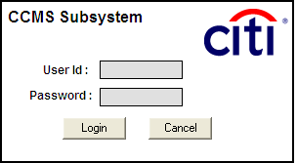

Parameter
Bank Information
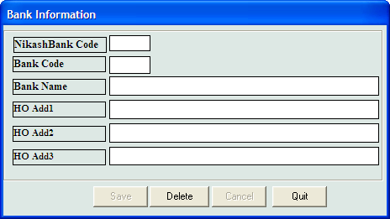
fig no (1)

The Bank Page is shown in fig no (1) is related to bank information. This form captures input of all clearing bank related information. This bank information will be required in the Nikash Entry form .There are some text boxes into the form. All those will take Bank related information from the user.
Search: After the Bank Code text box. According to the Bank Code, it will be displayed desired Bank related information.
Save: This button will save the text boxes value into the Bank table.
Delete: It will delete the record that will be given into the Bank Code field.
Cancel: This will clear all the text boxes value and temporary displayed element.
Quit: It will close the form.
Process:
- To search a bank name ,it is required to provide a Bank Code value and then press enter
- After providing all the information into text boxes, press save button to store into database.
- Enter a Bank Code value into the Bank Code text box and then press Delete button if you want to delete any record from database.
- For refreshing page, press Cancel button.

Branch Information

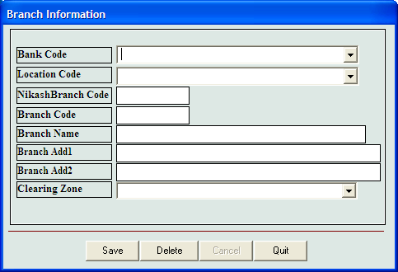
fig no (2)
Branch Information Page is shown in fig no (2) is related to Branch information. This form is used to input all clearing related bank branches information. This branch information will be required in the Nikash Entry form to select branches. There are text boxes in the form to capture branch related information.
Nikash Branch code is the branch code which is under central bank clearing house.
According to the Bank Code and branch code, it will display desired Bank related information.
Save: This button will save the text boxes value into the table.
Delete: It will delete the record that will be given into the Bank and nikashbranch code field.
Cancel: This will clear all the text boxes value and temporary displayed element.
Quit: It will close the form.
Process:
- To search a branch name ,it is required to provide a Bank Code value and then press enter
- After providing all the information into text boxes, press Save button to store into database.
- Enter a Bank Code value into the Bank Code text box and then press Delete button if you want to delete any record from database.
- For refreshing page, press Cancel button.

Client Information:
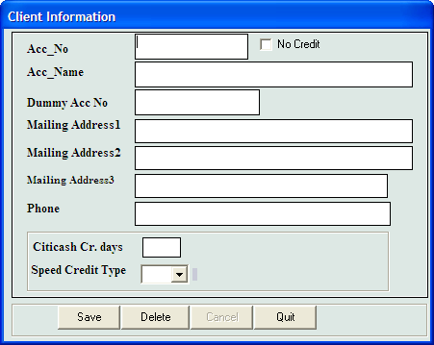

fig no (3)
Client Information Page is shown in fig no (3) is used to capture Client related information. This form is used to input A/C information of Citibank client. This client information is required in the Nikash Entry form to select cilent. There are text boxes in the form to capture client related information.
According to the Client Code, it will display desired client related information.
Save: This button will save the text boxes value into the client table.
Delete: It will delete the record that will be given into the client Code field.
Cancel: This will clear all the text boxes value and temporary displayed element.
Quit: It will close the form.
Process:
- To search a Client name ,it is required to provide a A/C no value and then press enter
- After providing all the information into text boxes, press Save button to store into database.
- Enter a Client Code value into the Client Code text box and then press Delete button if you want to delete any record from database.
- For refreshing page, press Cancel button.

Return
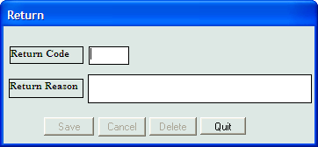

fig no (4)
Return Screen Page is shown in fig no (4) is used to capture return related information. This return code and reason information is used for returning checks.
According to the return Code, it will display desired return reason.
Save: This button will save the text boxes value into the return table.
Delete: It will delete the record that will be given into the return Code field.
Cancel: This will clear all the text boxes value and temporary displayed element.
Quit: It will close the form.
Process:
- To search a return name ,it is required to provide a return code and then press enter
- After providing all the information into text boxes, press Save button to store into database.
- Enter a return code into the return Code text box and then press Delete button if you want to delete any record from database.
- For refreshing page, press Cancel button.

Chque Type Information
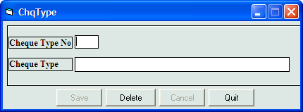

fig no (5)
ChqType Screen Page is shown in fig no (5) is used to keep Cheque Type related information. Cheque type refers to the type of clearing checks like MC, Customer checks etc.
According to the Cheque type no, it will display the desired Cheque type detail
Save: This button will save the text boxes value into the table.
Delete: It will delete the record that will be given into the Cheque Type no field.
Cancel: This will clear all the text boxes value and temporary displayed element.
Quit: It will close the form.
Process:
- To search a Cheque Type ,it is required to provide a Cheque Type code and then press enter
- After providing all the information into text boxes, press Save button to store into database.
- Enter a Cheque Type code into the Cheque Type code text box and then press Delete button if you want to delete any record from database.
- For refreshing page, press Cancel button.

BBK Account Information

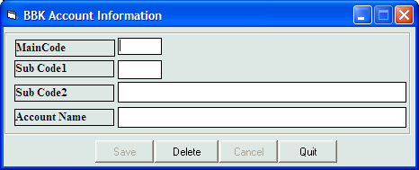
fig no (6)

BBK Account Information Screen Page is shown in fig no (6) is used to keep Bangladesh bank account information .It is required for Bangladesh bank check clearing
Save: This button will save the text boxes value into the corresponding table.
Delete: It will delete the record that will be given into the Main Code field.
Cancel: This will clear all the text boxes value and temporary displayed element.
Quit: It will close the form.
Process:
- To search a return name ,it is required to provide a Main code and then press enter
- After providing all the information into text boxes, press Save button to store into database.
- Enter a Main code into the Main Code text box and then press Delete button if you want to delete any record from database.
- For refreshing page, press Cancel button.

Holiday Information
This form is used to maintain holiday information .Screen allows user to keep information of annual holiday as well as Govt holiday.
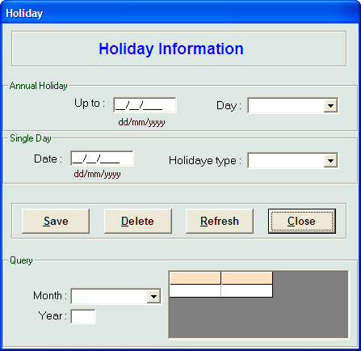

fig no (7)

Holiday Information Screen Page is shown in fig no (7) is used to keep annual and single govt holiday. This form automatically creates weekly holidays if annual holiday is inputted and select the Day as weekly holiday.
Save: This button will save the text boxes value into the corresponding table.
Delete: It will delete the record that once the holiday is selected from grid and press the delete button
Cancel: This will clear all the text boxes value and temporary displayed element.
Quit: It will close the form.
Process:
- After providing all the information into text boxes, press Save button to store into database.
- It will delete the record that once the holiday is selected from grid and press the delete button
- For refreshing page, press Cancel button.

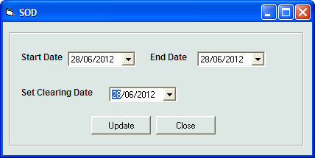
fig no (8)

SOD Screen Page is shown in fig no (8) is used to initialize the table and set the clearing date. This clearing date or processing date is refer to the date of the clearing house
Update : This button will save the information of the screen
Close : It will close the form.
Process:
- After providing all the information into text boxes, press Update button to store into database.
- Close the form after the clearing date is set.

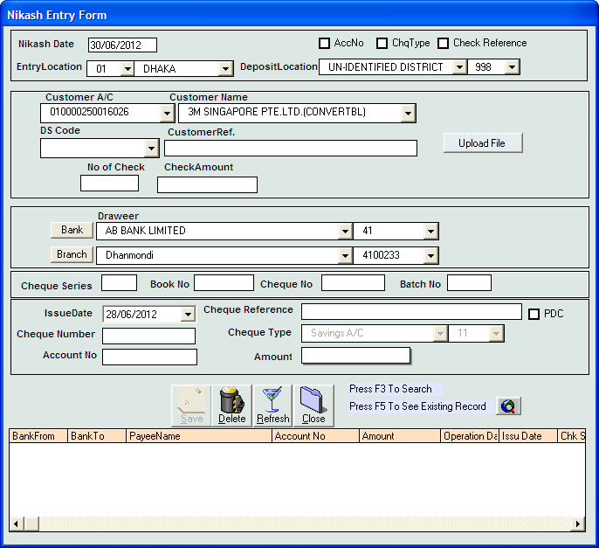
fig no (9)

Transaction form:

Nikash Entry form is the main form to capture clearing check details.

Process :

1)Nikash date is the default date once the date is selected by the department by the SOD screen.

2) User need to select checkboxes such as AccNo,ChqType,CheckReference to enable the input boxes for input.

3)User then need to select Citibank customer A/C no and name from the drop down for which check will be deposited.DS code , customer reference, no of check and check amount are the values which is mentioned in the deposit slip that is deposited by Citibank customer.

4) Select bank and branch code mention in the check.

5) Issue date, cheque reference , cheqnumber , ChequeType, Accountno, amount are the text boxes which are used to capture check detail entry. After providing amount in the amount box, user need to put enter so that cheque details comes in the grid .System will automatically check with the total amount and count of checks with the detail mention in “no of check” and “CheckAmount” field.

Once all check entry is completed then press save button.

To delete a check, Put deposit slip no and press enter .It will show all the check detail .User needs to select check from the grid and press save button.

Search : To see the existing record press search button.
Close : It will help to close the form.
Refresh : To clear all the values of the screen.

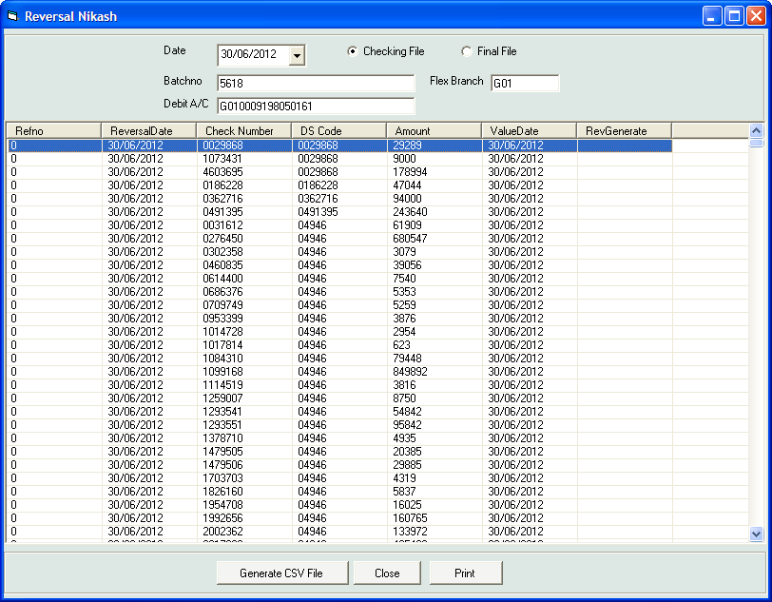
fig no (10)
After verifiying the check detail ,user can open the reversal nikash form to generate flexcube handoff file.Generate CSV file button is used to generate csv file.

Close : To close the form
Print : To print the hadoff detail

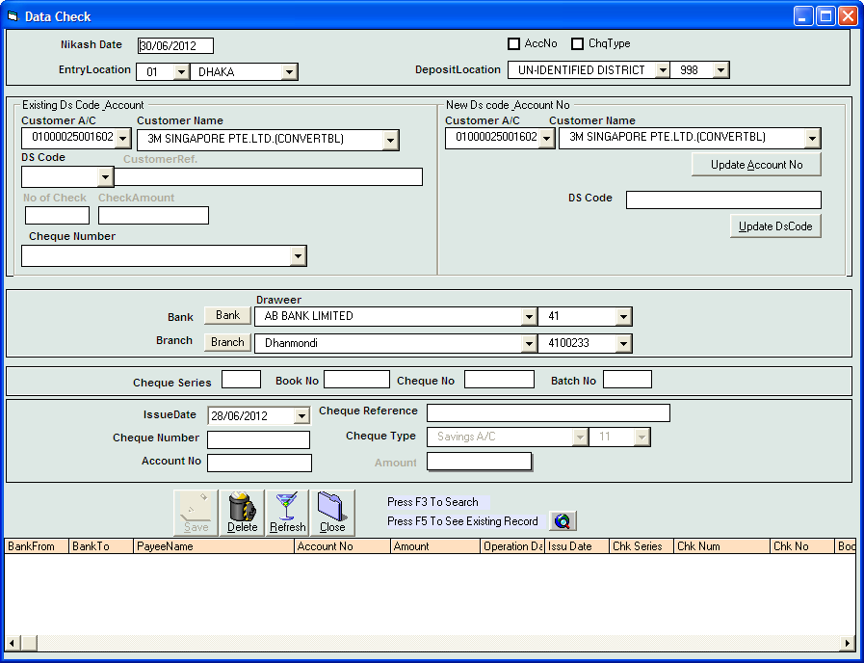

fig no (11)

Data Check:
This screen will allow user to check individual detail of the check .If any discrpency is found ,user can correct information from the screen by selecting the check from the dropdown “CheckNumber” control.

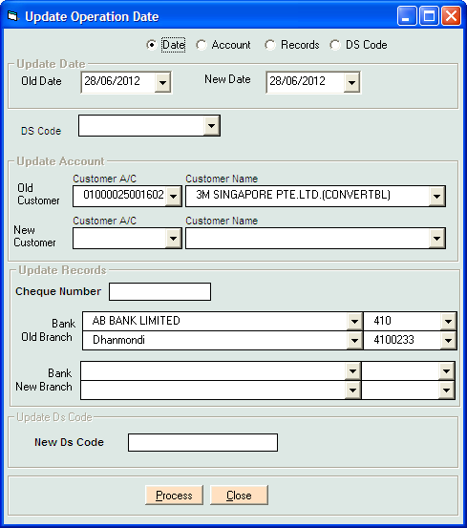
fig no (12)

Updatedate:
Using this option of the screen will help to update clearing date of all checks in deposit slips.
Update Account:
Using this option of the screen will help to update A/C of all checks in deposit slips.
Update Bank:
Using this option of the screen will help to update bank branch all checks in deposit slips.

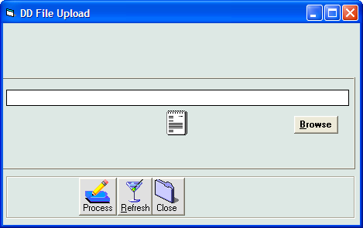

fig no (13)

This screen will allow user to upload DDE file which comes from CCMS system. User can select file from browse option and press process button.

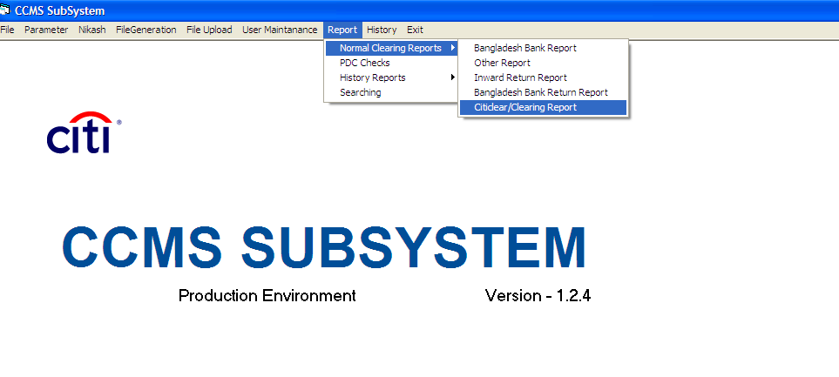

fig no (14)

Report:
System has several reports for MIS reporting and reconciliation .Reports like bank wise check summery report, bank branch wise check detail report. Client wise check detail & summery report.

